FORNAX™ ePlanCheck Rule
Rule Information
Rule ID | SWD 4.2.4
Rule Name | Provision of Drainage System Towards Adjacent Premises
Chapter | 4 Drainage Planning Requirements
Section | 4.2 Drainage Affecting Other Premises
Handbook | 7th Edition Code of Practice on Surface Water Drainage (Dec 2018)

Rule Description
    - If a development site is sloping towards the adjacent premises, a drainage system shall be provided along the site boundary to prevent the runoff from discharging into adjacent premises.

Rule Interpretation
- This rule checks for the provision of drainage system along the boundary of a development site when sloping towards other properties. It prevents the runoff water going down to other properties.
DRAINAGE SYSTEM
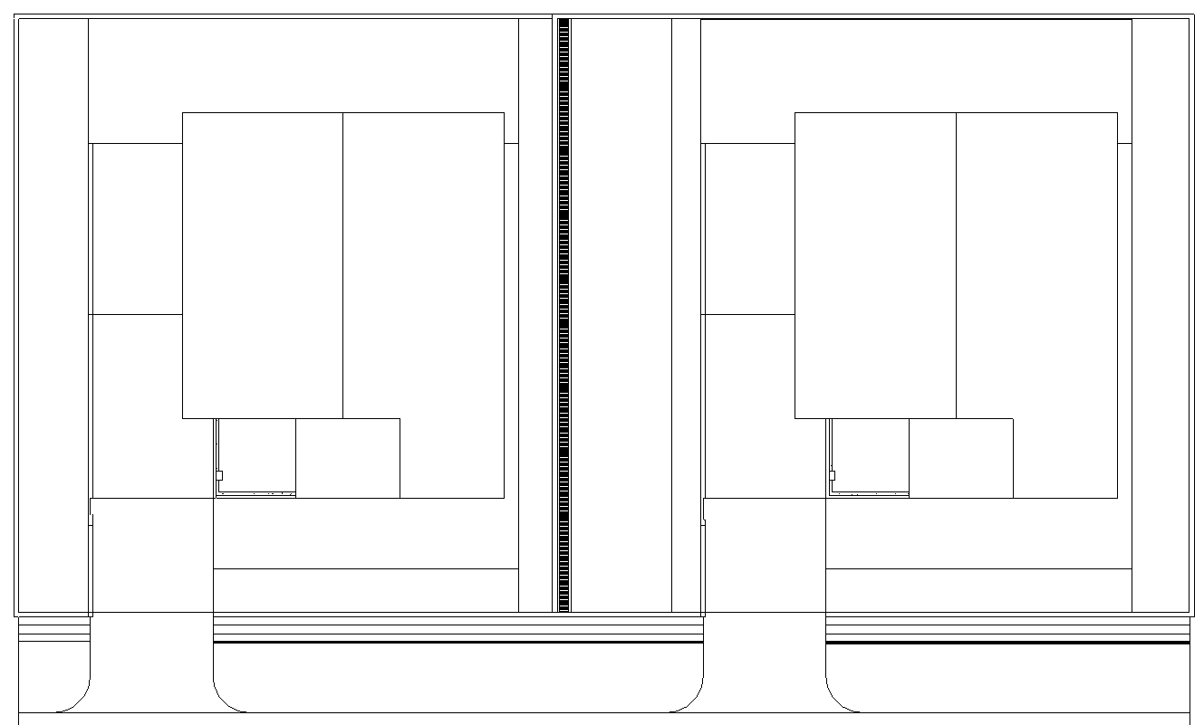

PROPERTY A
PROPERTY B

BOUNDARY WALL

Drainage System along Site Boundary Plan View
FIGURE 01

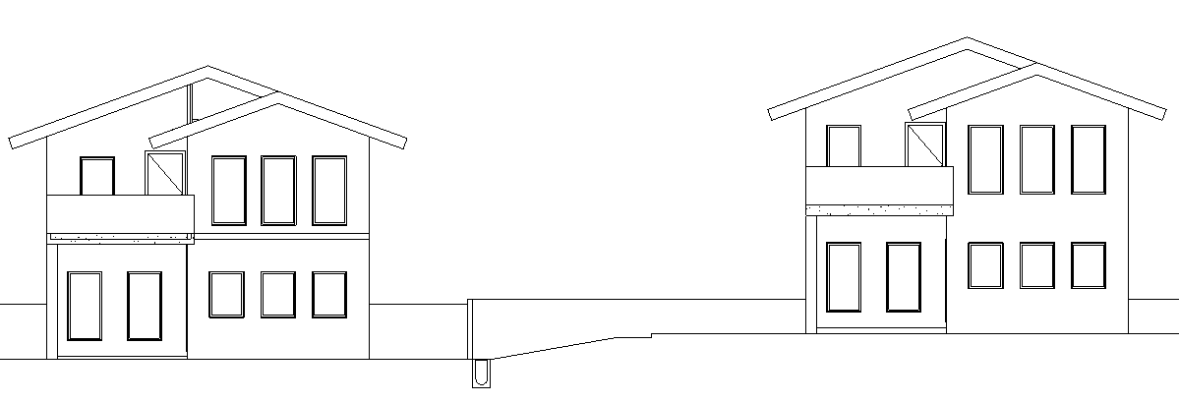

BOUNDARY WALL

PROPERTY B
PROPERTY A
DRAINAGE SYSTEM
Drainage System along Site Boundary Elevation View
FIGURE 02

Rule Scenario

Scenario 01 – Compliant
Requirement | Provision of drainage system along the boundary of a development site when sloping towards other properties
Description | Property B is sloping towards Property A. Drainage system is provided along the boundary of Property B.
DRAINAGE SYSTEM

PROPERTY A
PROPERTY B

BOUNDARY WALL

PLAN
FIGURE SCENARIO

BOUNDARY WALL

PROPERTY B
PROPERTY A
DRAINAGE SYSTEM

SECTION

FIGURE SCENARIO

Scenario 01 – Non-Compliant
Requirement | Provision of drainage system along the boundary of a development site when sloping towards other properties
Description | Property B is sloping towards Property A. No drainage system provided along the boundary of Property B.
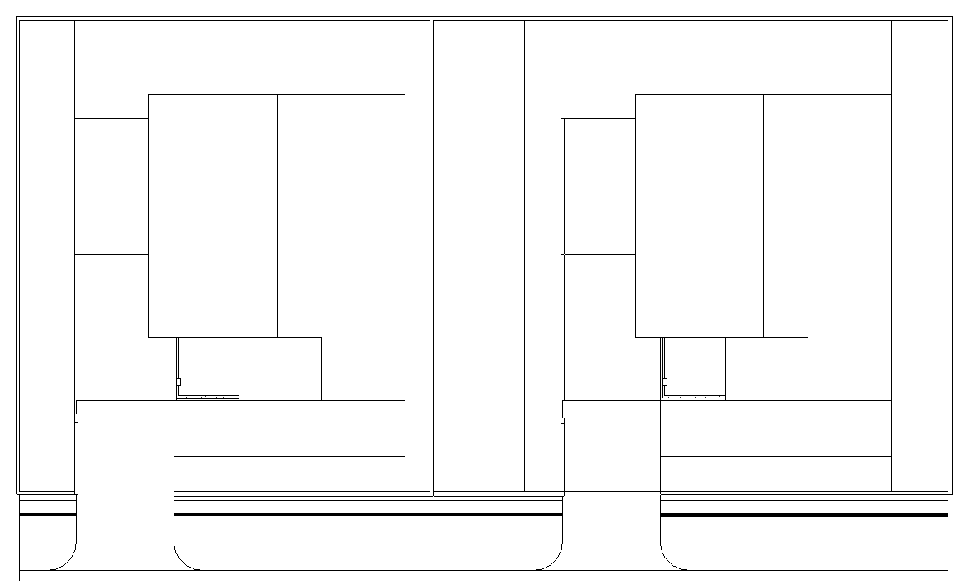

PROPERTY A
PROPERTY B

BOUNDARY WALL

PLAN
FIGURE SCENARIO

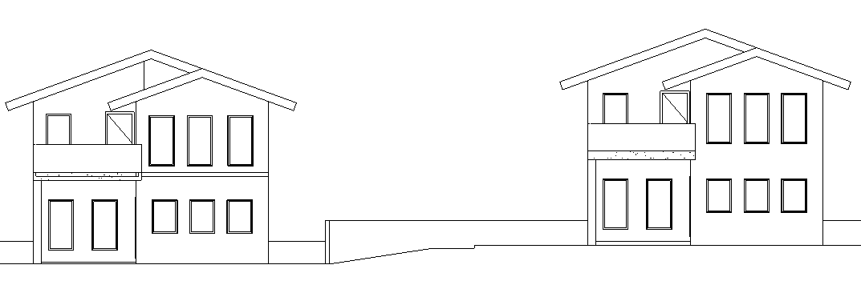

BOUNDARY WALL

PROPERTY B
PROPERTY A

SECTION

FIGURE SCENARIO

Model PreCheck

Required Elements | Required Attributes
PipeSegment | ObjectType contains “Drainage System”
Space | LongName contains “Property A”, “Property B”

Rule Parameters

Element Type 1
State | Type | Property | Operator | Value
Include | PipeSegment | ObjectType | Contains | Drainage System
Exclude |  | Any | Match | N.A.
 |  |  | N.A. | <User defined>

Element Type 2
State | Type | Property | Operator | Value
Include | Slab | ObjectType | Contains | Slope
Exclude |  | Any | Match | N.A.
 |  |  | N.A. | <User defined>

Space Type 1
State | Property | Operator | Value
Include | LongName | Contains | Property A
Exclude | Name | Match | <User defined>

Space Type 2
State | Property | Operator | Value
Include | LongName | Contains | Property B
Exclude | Name | Match | <User defined>

Element Type 1 Condition
* Shall be provided on the boundary of Space Type 2.

Space Type 2 Condition
* Shall be adjacent to Space Type 1.

* Shall be higher than Space Type 1.

Result Messages
- 4.2.4 Provision of Drainage System Towards Adjacent Premises
  - Non-Compliant (TotalResultNumeric)
    - SpaceTypeNumeric
      - ElementType1Value is not provided along boundary of SpaceType2Value.
  - Compliant (TotalResultNumeric)
    - SpaceTypeNumeric
      - ElementType1Value is provided along boundary of SpaceType2Value.
  - Attention (TotalResultNumeric)
    - ElementType2Value is not provided.

Sample Result Messages
- 4.2.4 Provision of Drainage System Towards Adjacent Premises
  - Non-Compliant (1)
    - Space 1
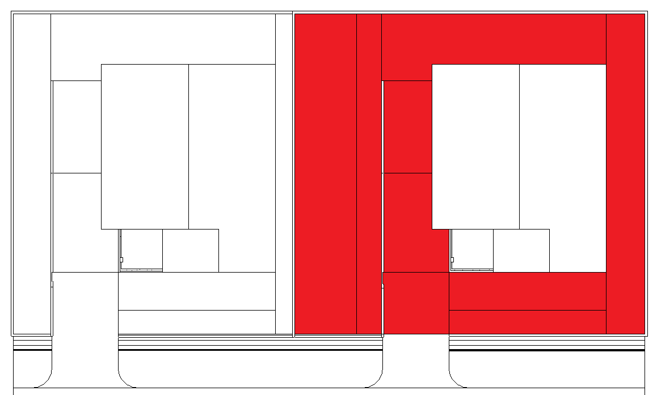
      - Drainage system is not provided along boundary of Property B.

PLAN

  - Compliant (1)
    - Space 1
      - Drainage system is provided along boundary of Property B.
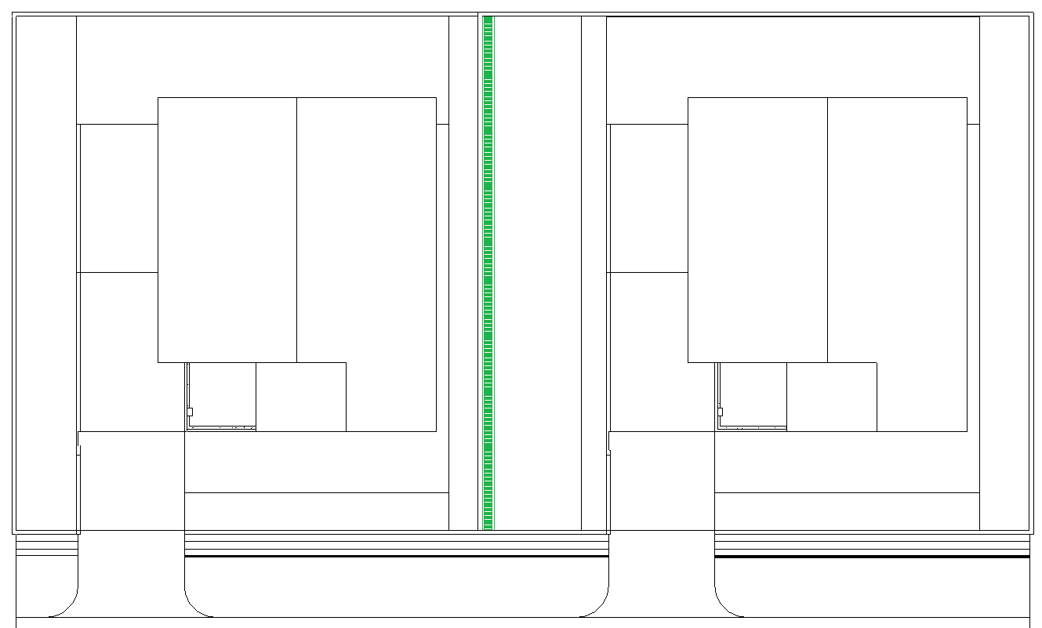

PLAN

  - Attention (1)
    - Slope is not provided.

Sample Result Model Views
- 4.2.4 Provision of Drainage System: Slope Towards Adjacent Premises
- Non-Compliant
- Plan/Top view.
    - Highlight checked element/space.
    - All other elements are in translucent except checked element/space.
- Compliant
- Plan/Top view.
- Highlight checked element/space.
- All other elements are in translucent except checked element/space.

Testing Scenario Notes
- Scenario 01 Non-Compliant
- Space 1
- Property B is sloping towards Property A. No drainage system provided along the boundary of Property B.

- Scenario 01-Compliant
- Space 1
- Property B is sloping towards Property A. Drainage system is provided along the boundary of Property B.

Model:
SWD 4.2.4 Scenario 01 Non-Compliant.ifc
SWD 4.2.4 Scenario 01 Compliant.ifc

Modelling Guideline
- Specify ObjectType containing “Drainage System” for relevant PipeSegment.
- Specify LongName containing “Property A” and “Property B” for relevant Space.

Specification Log
RA | Reymart Sisgon
Last edit date | 03 December 2018
ePC version
Updates | - V1

